**PERFORMANCE MATRIX**

The performance matrix used here is Confusion Matrix. We have computed accuracy, precision, Recall and F1 Score for all the NER category based on which we have used micro F1 score as our evaluation matrix.

1. For **Eng Data**, the details are found below:

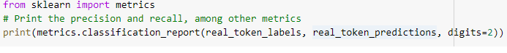

precision recall f1-score support

0 0.72 0.76 0.74 54

1 0.94 0.92 0.93 451

2 0.95 0.96 0.95 720

3 0.00 0.00 0.00 8

4 0.94 0.93 0.94 226

5 0.91 0.91 0.91 856

6 0.93 0.88 0.91 456

7 0.79 0.76 0.77 491

8 0.88 0.73 0.80 222

9 0.41 0.29 0.34 56

10 0.47 0.16 0.23 45

11 0.92 0.95 0.94 812

12 0.89 0.78 0.83 119

13 0.66 0.69 0.67 90

14 0.97 0.98 0.97 14929

15 0.89 0.90 0.90 562

16 0.90 0.90 0.90 403

17 0.78 0.69 0.73 496

18 0.96 0.98 0.97 610

19 0.58 0.56 0.57 75

20 0.97 0.97 0.97 500

21 0.81 0.87 0.84 30

22 0.94 0.87 0.91 496

23 0.93 0.95 0.94 862

24 0.95 0.96 0.95 1117

accuracy 0.94 24686

macro avg 0.80 0.77 0.78 24686

weighted avg 0.94 0.94 0.94 24686

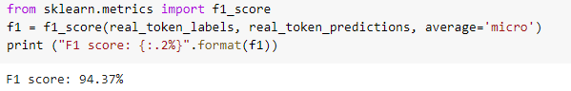

Accuracy achieved is : 94%

1. For **trivial10k13 Data,** the details are found below:



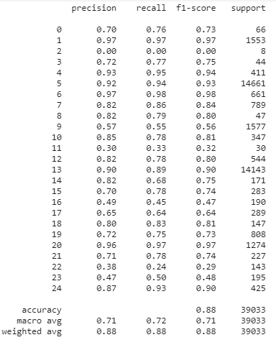

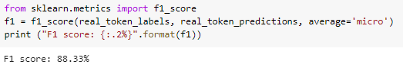

Accuracy = 88%